

School of Digital, Technology, Innovation, and Business
Department of Engineering

Mechanism Design & Optimisation
Report

Student Name: Arpan K Roy
Module Code: MECH43024
Course: Engineering Design & Practice (MECH43024)
Word Count: 3193
Deadline: 01/05/2026
Table of Contents
1. Introduction and Project Planning 4
1.1 Project Scope 4
1.2 Methodology 4
1.3 Resources and Constraints 4
1.4 Project Management (Gantt Chart) 5
2. Research 6
2.1 Product and Market Research 6
2.2 Selection of Materials 7
2.3 Manufacturing Process 7
2.4 Health and Safety Considerations 8
3. Design Development 9
3.1 Initial Concepts 9
3.2 Design Features of Product 10
3.3 Pugh Matrix 11
3.4 2D CAD Layout for Concept 4: 12
4. Product Design Specifications 13
5. CAD Design and Documentation 14
5.1 Assembly Model 14
5.2 Component Drawing 15
5.3 Bills of Materials 16
6. Prototyping Process 17
6.1 Workshop Attendance 17
6.2 CNC Lathe Machining 17
6.3 Laser Cutting 18
6.4 Metal Workshop 19
7. Assembly and Reflection 20
7.1 Assembly Process 20
7.2 Comparison with CAD MODEL 21
7.3 Reflection and Recommendations 21
7.4 Sustainability Considerations 22
References 23

List of Figures
Figure 1. Gantt Chart: Mini-Sellotape Dispenser Project 5
Figure 2. Desktop Tape Dispenser 6
Figure 3. Handheld Tape Dispenser 6
Figure 4. Ergonomic Tape Dispenser 7
Figure 5. Protective Toe Caps 8
Figure 6. Safety Goggles 8
Figure 7. Safety Gloves 8
Figure 8. Basic Rectangular Dispenser 9
Figure 9. Vertical Desk Tape Dispenser 9
Figure 10. Enclosed Tape Dispenser 10
Figure 11. Rectangular Tape Dispenser 10
Figure 12. 2D CAD Layout 12
Figure 13. Assembly Model (unexploded view) 14
Figure 14. Assembly Model (exploded view) 15
Figure 15. Spindle 15
Figure 16. CNC Lathe Machine 17
Figure 17. CNC Lathe Machine Controller 17
Figure 18. Laser Cutting Machine 18
Figure 19. Laser Cutter 18
Figure 20. Metal Workshop 19
Figure 21. Wooden File Handle 19
Figure 22. Final Product (Left View) 20
Figure 23. Final Product (Right View) 20
List of Tables
Table 1. Pugh Matrix 12
Table 2. PDS 14
Table 3. Bill of Materials 17

Introduction and Project Planning

1.1 Project Scope
The scope of the project is to design, develop, and manufacture a functional prototype of a Mini-Sellotape Dispenser using the provided materials and workshop facilities. The project involves applying fundamental engineering principles, including manufacturing processes, CAD modelling, and assembly techniques, to produce a working prototype and to provide comprehensive documentation of the design and manufacturing process. This project also includes comprehensive research into existing products, the generation of design concepts, and the evaluation and selection of the final design.

1.2 Methodology
A structured engineering design approach was adopted to ensure systematic development of the product. The project was divided into key stages: research, concept generation, design evaluation, CAD modelling, prototyping, and final assembly of the product.
Initially, background research was conducted to understand existing tape dispenser designs and identify key functional requirements. This was followed by the generation of multiple design concepts, and the most suitable option was selected.
CAD software was then used to create detailed 2D and 3D models of the selected concept. These models were used to guide the manufacturing process. Prototyping was carried out through Technical Instruction sessions, involving CNC Lathe TI, Laser Cutting TI, and metal workshop practices.

1.3 Resources and Constraints
The project utilised a range of resources, including workshop machinery, CAD software, and a Mini-Sellotape Dispenser kit. Key resources include the CNC lathe machines for machining cylindrical components, laser cutting equipment for acrylic parts, and the general metal workshop for the manual fabrication process.
However, several constraints influenced the design and manufacturing process. Time limitations require that the project be completed within a fixed schedule (about 6-8 weeks), restricting the complexity of the design. Material availability was limited to the components provided in the kit, which influenced design decisions such as dimensions and structural configuration.
Additionally, strict adherence to university health and safety regulations and the availability of workshop slots necessitated careful planning and scheduling. The capabilities and limitations of the available tools and materials also influenced design decisions.

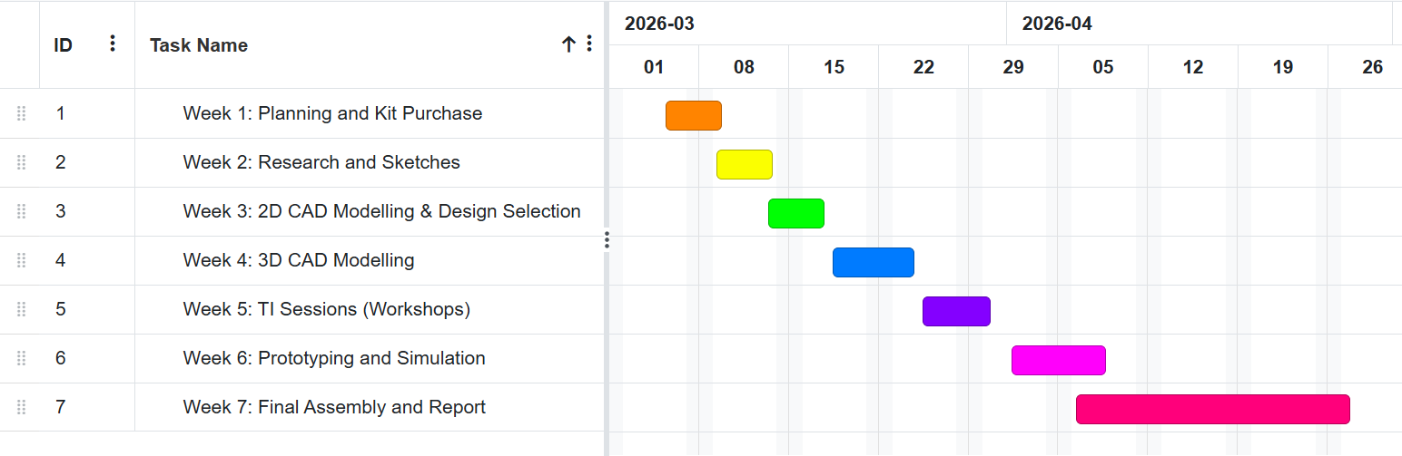
1.4 Project Management (Gantt Chart)
Figure 1. Gantt Chart: Mini-Sellotape Dispenser Project
Effective project management was essential to ensure the completion of all stages within the allotted time. A Gantt chart was used to plan and monitor progress throughout the project. This tool provided a clear visual representation of task sequences, durations, and dependencies between different phases. It also helped identify potential delays and allowed adjustments to be made to maintain overall project progress.

Research

2.1 Product and Market Research
Tape dispensers are widely used products designed to hold, dispense, and cut adhesive tape efficiently. Existing designs range from simple handheld plastic dispensers to more desktop models with weighted bases for stability. Common features include a spindle for holding the tape roll, a cutting blade, and a supporting structure.
Ashby (2011) highlights that successful product design must balance manufacturability, safety, and functionality. In contrast, many mass-produced tape dispensers focus primarily on cost-effective manufacturing methods such as plastic injection moulding, often compromising durability and environmental sustainability (Boothroyd et al., 2010).
Furthermore, there is an increasing trend towards the development of ergonomic and automated dispensers aimed at improving user comfort and operational efficiency, particularly within packaging applications (Pahl and Beitz, 2014).
Three common tape dispensers used in various settings are as follows:

Figure 2. Desktop Tape Dispenser
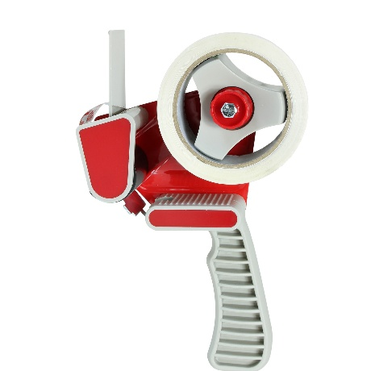
Figure 3. Handheld Tape Dispenser
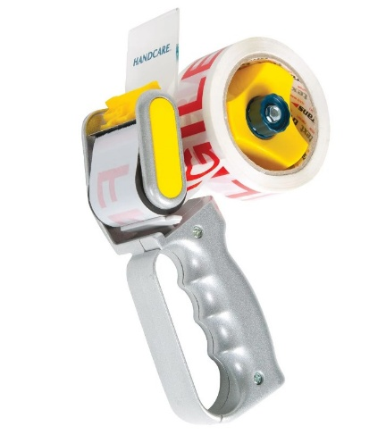
Figure 4. Ergonomic Tape Dispenser

2.2 Selection of Materials
Material selection plays an important role in determining the performance, durability, and manufacturability of the product. The main materials considered for this project were aluminium, acrylic, and mild steel.
Aluminium was selected for structural components due to its lightweight nature, good corrosion resistance, and excellent machinability, making it suitable for CNC lathe operations (Kalpakjian and Schmid, 2014). Acrylic was used for non-load-bearing components because it is easy to laser cut and provides a clean finish (Ashby, 2011). Mild steel was primarily used for the cutting blade due to its strength and ability to maintain a sharp edge.
The combination of all these elements ensures a balance between strength, weight, manufacturability, and cost. Furthermore, recyclable materials such as acrylic and aluminium help achieve sustainability and reduce environmental impact.

2.3 Manufacturing Process
The manufacturing of the Mini-Sellotape Dispenser involved three key processes: CNC lathe machining, laser cutting, and metal workshop operations.
- CNC Lathe Machining: This method was employed to produce a cylindrical component, the spindle. This process offers high precision, repeatability, and good surface finish, in accordance with CAD models, making it ideal for rotating parts (Kalpakjian and Schmid, 2014).
- Metal Workshop Fabrication: Manual metal workshop processes, such as drilling, filing, and tapping, were used to manufacture smaller components. These processes provided flexibility for adjustments and finishing operations. Throughout, safety precautions were taken to avoid accidents, particularly while using machinery and sharp objects.
- Laser cutting: Laser cutting was used to produce acrylic components with high accuracy and minimal material waste. Because of its great accuracy and low material waste, laser cutting allowed for complex cutting and personalisation, including engraving text or logos (Groover, 2015).

2.4 Health and Safety Considerations
Health and safety were critical throughout the manufacturing process. Personal protective equipment (PPE), including safety goggles, gloves, and protective footwear, was always worn in the workshop.
Before operating machinery such as the CNC lathe and laser cutter, proper training and supervision were provided. Risks such as sharp edges, rotating machinery, and high temperatures were identified and managed through safe working practices.

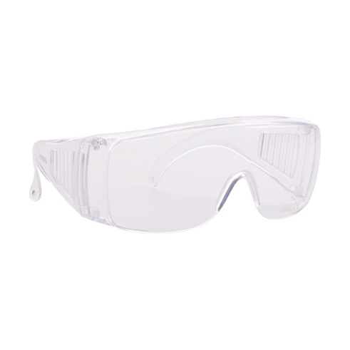
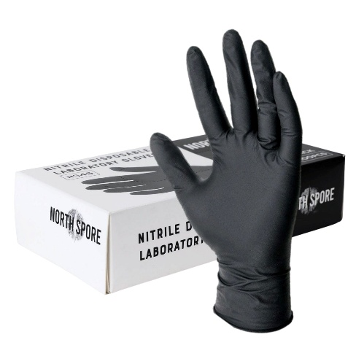
Figure 5. Protective Toe Caps
Figure 6. Safety Goggles
Figure 7. Safety Gloves

Design Development

3.1 Initial Concepts
Three initial design ideas were selected for the Mini-Sellotape Dispenser and are shown below:
Concept 1: Basic Rectangular Dispenser
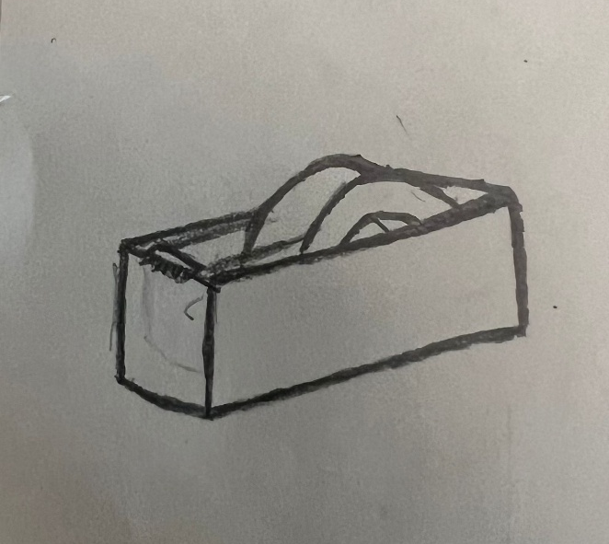
Figure 8. Basic Rectangular Dispenser
Concept 2: Vertical Desk Tape Dispenser
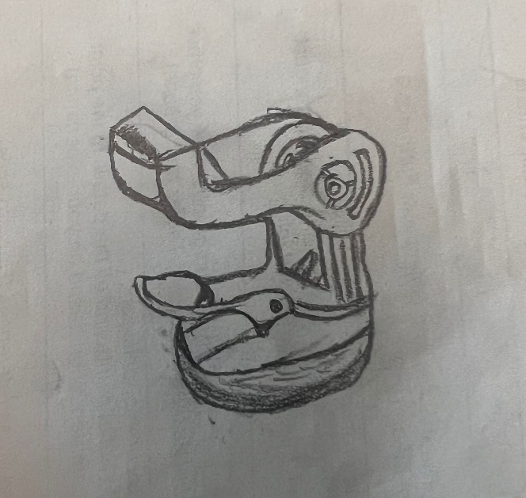
Figure 9. Vertical Desk Tape Dispenser

Concept 3: Enclosed Tape Dispenser
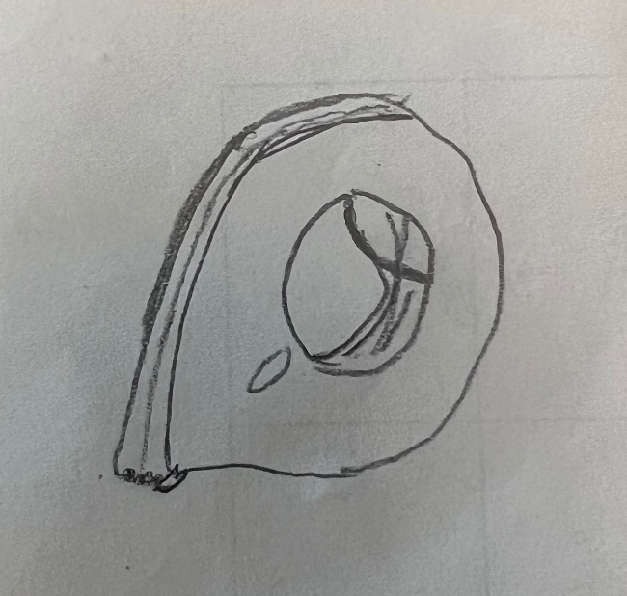
Figure 10. Enclosed Tape Dispenser
Concept 4: Rectangular Tape Dispenser
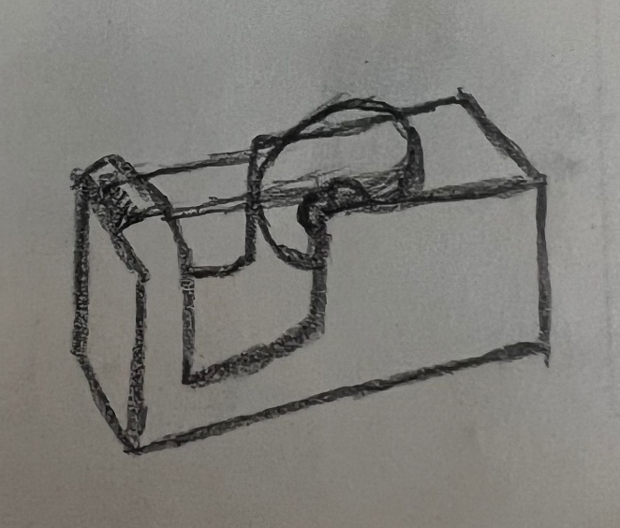
Figure 11. Rectangular Tape Dispenser

3.2 Design Features of Product
The essential elements and their characteristics required for a functional and efficient tape dispenser are as follows:
Tape Holder/Spindle: A cylindrical component designed to hold the tape securely while consistently allowing smooth rotation during dispensing.
Cutting Blade: A sharp, small metal piece positioned at the front of the dispenser, used to cut the tape cleanly while maintaining safety.
Support Base: A stable base structure that provides balance and prevents movement during use.
Handle or Finger Grip: A feature incorporated into ergonomic models to improve user control and comfort, particularly in handheld designs.
Protective Edge/Cover: A safety feature designed to partially enclose or shield the cutting blade when not in use, reducing the risk of accidental injury.

3.3 Pugh Matrix
The four design concepts were evaluated using the Pugh matrix, a decision-making tool commonly used in engineering design to compare multiple concepts against a set of defined criteria, which are functionality, aesthetics, safety, ease of manufacturing, and stability.
Table 1. Pugh Matrix
Criteria | Concept 1 (Baseline) | Concept 2 | Concept 3 | Concept 4
Functionality | 0 | +1 | +1 | +1
Ease of Manufacture | 0 | -1 | -1 | +1
Aesthetics | 0 | +1 | +1 | +1
Safety | 0 | +1 | +1 | +1
Stability | 0 | -1 | +1 | +1
Total Score | 0 | +1 | +3 | +5
Note: “0” = same as baseline, “+1” = better than baseline, “-1“= worse than baseline
The results prove that Concept 4 achieved the highest overall score. This concept performed consistently well across all criteria, particularly in stability and functionality, suggesting a well-balanced design.
In contrast, Concept 2 showed reduced stability due to its geometry, while Concept 3 scored lower in ease of manufacture due to its complexity and additional processing requirements.
Concept 4 was selected because of its wider base, which improves stability, its simpler geometry, which facilitates easier manufacturing, and its optimised blade positioning, which provides better operational safety.
Overall, Concept 4 offers the best compromise between performance, manufacturability, and user safety. This selection is supported by the systematic evaluation provided by the Pugh matrix, ensuring that the decision is based on objective engineering judgement.

3.4 2D CAD Layout for Concept 4:
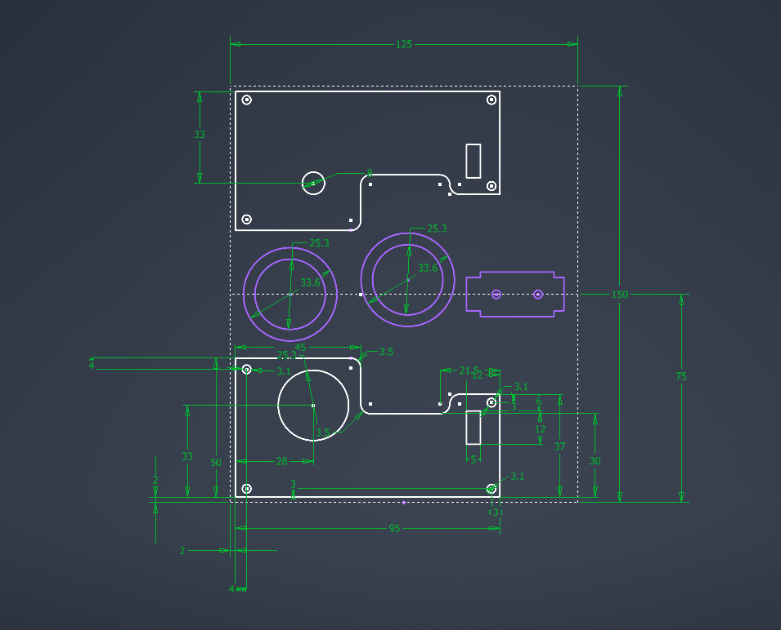
Figure 12. 2D CAD Layout

Product Design Specifications

By offering a sturdy base, accommodating standard tape widths (24–26 mm), and adding a guarded cutting mechanism to improve safety, the finished design satisfies PDS criteria.
Table 2. PDS
Category | Metric | Typical Value
Tape Compatibility | Width Capacity | Supports 24–26 mm tape rolls
Durability | Load Resistance | Maintains shape under ~1–2 kg applied force
Safety | Cutting Mechanism Protection | Guarded or recessed blade design
Ergonomics | Handling Comfort | Contoured grip with smooth edges
Environment | Operating Conditions | Indoor use, dry conditions, 15–35°C
Material | Construction Materials | Aluminium body with acrylic casing
Size | Overall Dimensions | Approx. 95 mm × 50 mm × 45 mm (based on tape roll size, width, height for user comfort)
Performance | Cutting Action | Clean single-motion cut for standard tape
Maintenance | Serviceability | Quick, tool-free blade replacement
Appearance | Visual Design | Transparent acrylic cover with matte metal base
Target Product Cost | Manufacturing Cost | Below £12 per unit
Product Life Span | Expected Lifetime | Around 2–4 years with moderate usage
Standards | Roll Compatibility | Fits rolls up to 26 mm width, ~50 mm core diameter

CAD Design and Documentation

5.1 Assembly Model
Autodesk Inventor Professional was used to create individual component models, which were then assembled to form the final product. The components were constrained using appropriate joints and secured with standard fasteners to ensure accurate alignment and functionality. The assembled components include:
- Main frame: Offers structural support and alignment of components.
- Spindle: The Sellotape roll is held in place and rotated by the spindle and side discs.
- Cutting mechanism: Located in the front, this device uses a sharp blade to cut tape.
- Fasteners: To join the parts, bolts and screws were provided in the kit.
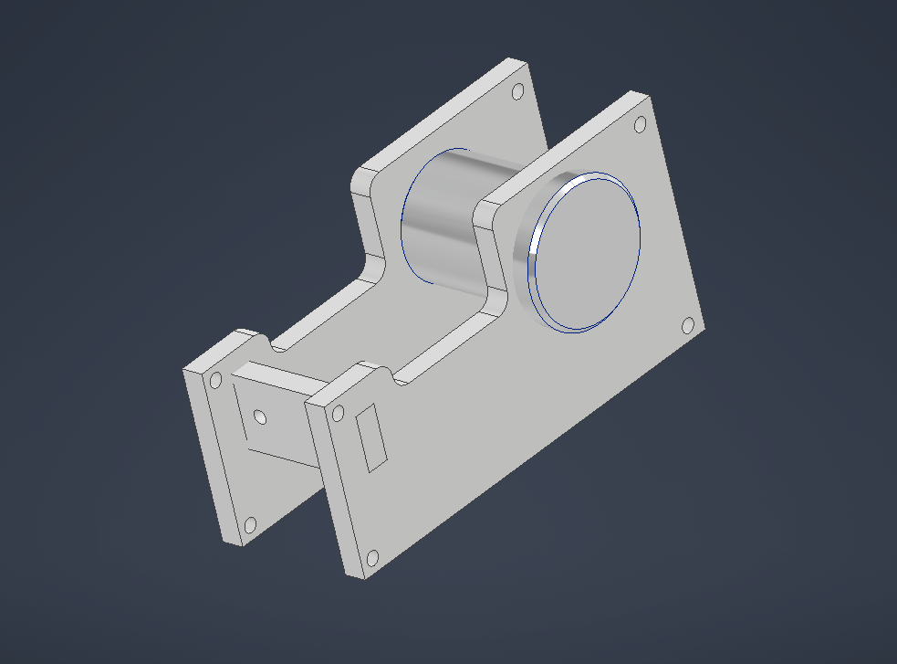
Figure 13. Assembly Model (unexploded view)

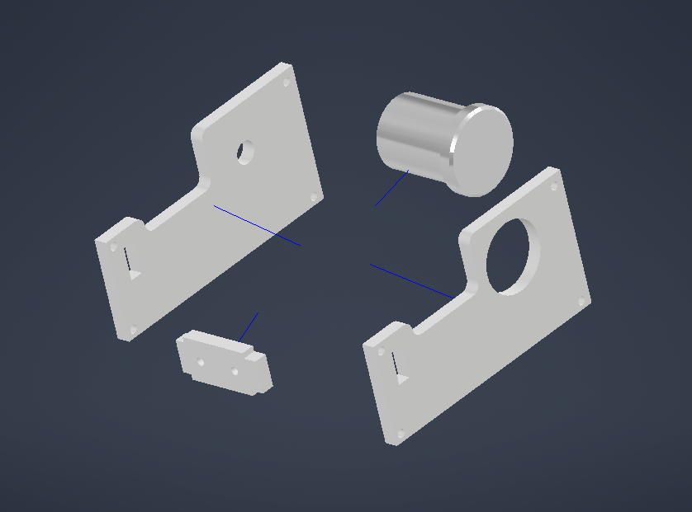
Figure 14. Assembly Model (exploded view)

5.2 Component Drawing
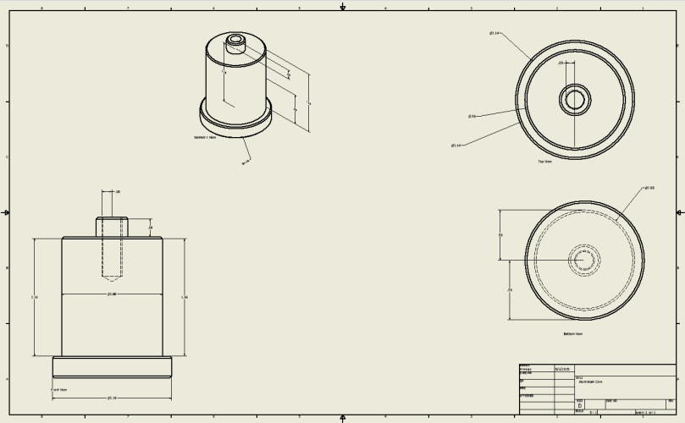
Figure 15. Spindle

5.3 Bills of Materials
The Bill of Materials lists all components required to assemble the product, including their material and quantity. This is essential for production planning, cost estimation, and ensuring all necessary parts are available during assembly.
Table 3. Bill of Materials
Item no. | Part Name | Material | Quantity
1 | Tape Spindle | Aluminium | 1
2 | Screws | Steel | 4
3 | Tape Cutter | Steel | 1
4 | Base Plate | Acrylic | 1

Prototyping Process

6.1 Workshop Attendance
The prototyping phase involved attending Technical Instruction sessions for CNC lathe machining, laser cutting, and metal workshop practices. These sessions provided hands-on experience with manufacturing equipment and ensured safe and correct usage.

6.2 CNC Lathe Machining
The CNC lathe was used to machine the spindle with high precision. The process involved setting up the material, defining the tool path, and executing the machining operation. The CNC lathe machining process was carried out in the following steps:
- An aluminium round bar was selected according to the PDS for the spindle and securely fixed in the lathe chuck to ensure stability.
- The zero-reference point was established and set to define the starting point.
- The CNC program (G-code) was loaded into the machine, and a tool path simulation was performed to check for errors before machining.
- The machining process was executed to achieve the required diameter and surface finish, after which the component was removed and deburred to remove any sharp edges and ensure safe handling during assembly.
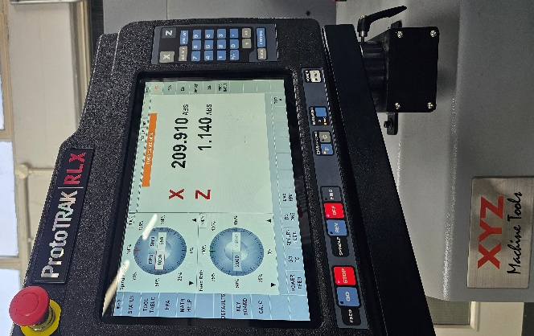
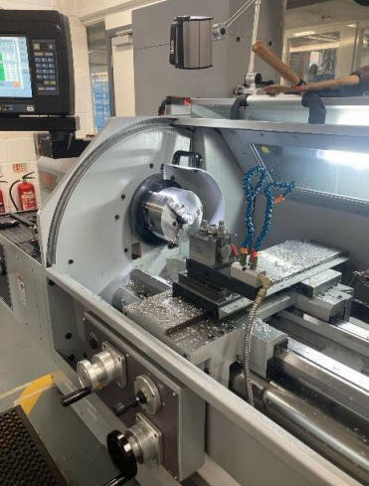
Figure 16. CNC Lathe Machine
Figure 17. CNC Lathe Machine Controller

6.3 Laser Cutting
Laser cutting was used to produce accurate profiles of acrylic components with precise dimensions. The process involved exporting CAD designs, setting machine parameters, and cutting the material. The laser cutting procedure was carried out in the following steps:
- The 2D CAD design was exported in DXF format to make it compatible with the laser cutting machine.
- The clear acrylic sheet was placed and aligned on the laser cutter bed to minimise waste and maximise material use.
- Adjusting to appropriate cutting parameters (power, speed, frequency) based on material thickness (5 mm acrylic).
- A test cut was performed to verify settings and accuracy, and the laser cutting process was then executed to produce the required components.
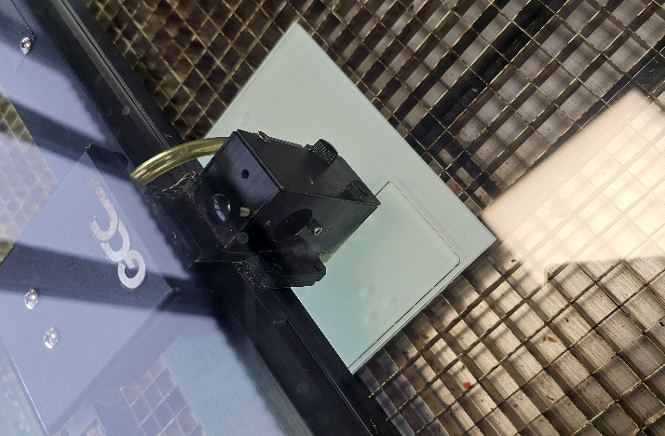
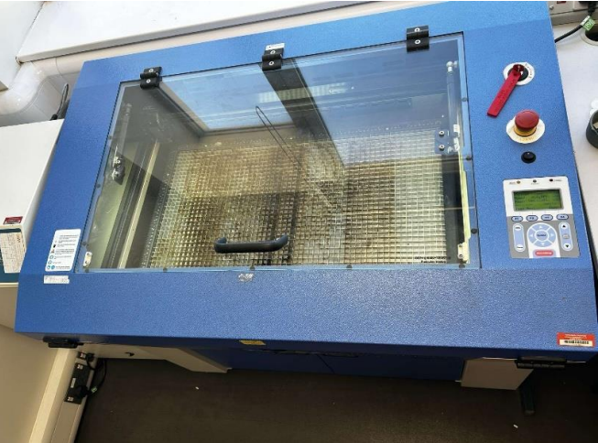
Figure 18. Laser Cutting Machine

Figure 19. Laser Cutter

6.4 Metal Workshop
The metal workshop was used to sharpen the cutting blade and to drill a hole in the spindle to accommodate the assembly of components. The following processes were carried out:
- Metal components were marked out using scribers and centre punches based on the CAD design.
- Holes were drilled using a pillar drill to accommodate bolts and screws in the spindle.
- Tapping was carried out to create internal threads for screws on the spindle.
- Metal components were cut to the appropriate length using tools such as a hacksaw or bandsaw.
- Edges were filed to remove burrs and improve safety.
- All parts were checked for dimensional accuracy and prepared for assembly.

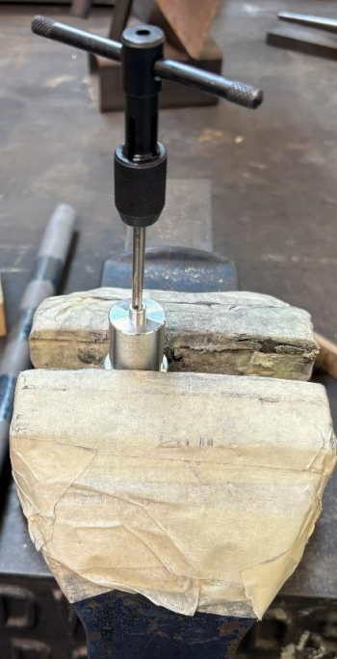
Figure 20. Metal Workshop

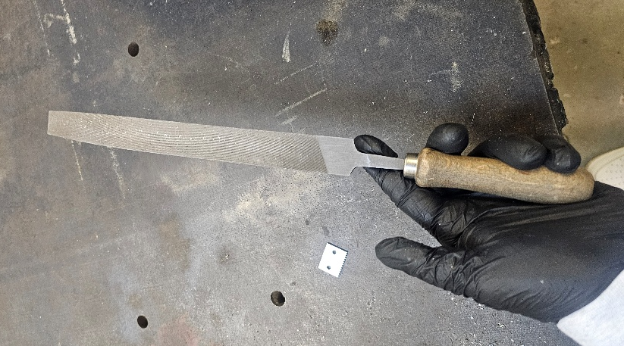
Figure 21. Wooden File Handle

Assembly and Reflection

7.1 Assembly Process
The final prototype of the Mini-Sellotape Dispenser was assembled by joining all the manufactured components using appropriate fasteners and alignment techniques. The assembly process was carried out in the following stages:
- Joining the base and side walls: The acrylic side panels were aligned and secured to the base using M4 bolts and nuts; they were aligned perpendicular for structural stability.
- Mounting of Spindle: The spindle, made on a CNC lathe machine, was positioned between the side panels and screwed in place for smooth rotation of the tape roll.
- Tape cutter attachment: The cutting blade was screwed to the front section of the structure; correct positioning was ensured by placing the blade parallel to the tape path for efficient cuts.
- Final adjustments: To ensure proper fit, smooth spindle rotation, and correct positioning of the cutting edge, a few final adjustments were made.
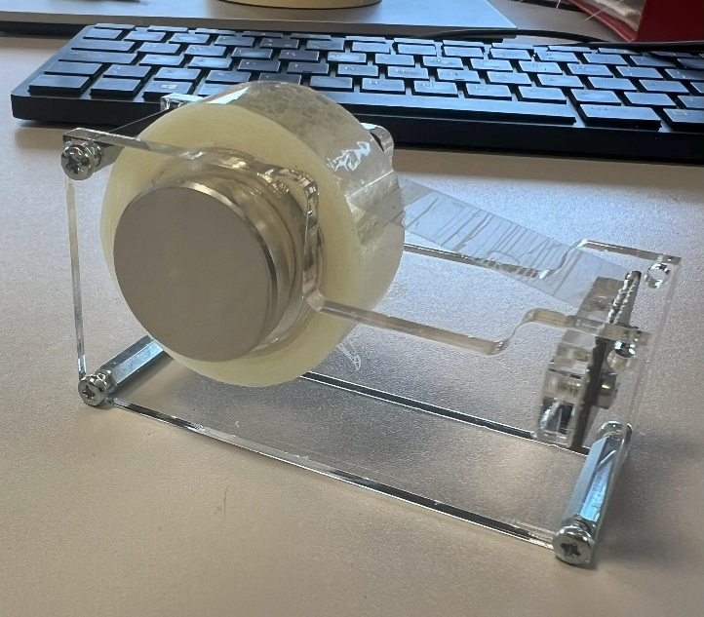
Figure 22. Final Product (Left View)
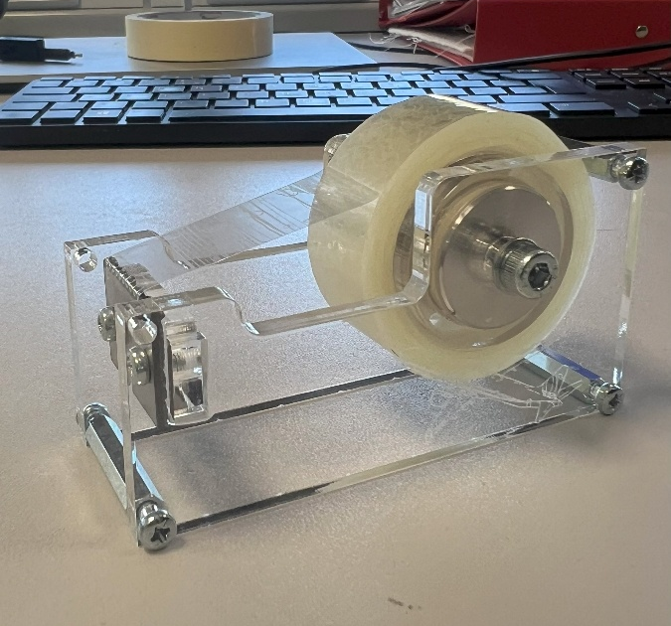
Figure 23. Final Product (Right View)

7.2 Comparison with CAD MODEL
The final prototype closely matched the original CAD model in terms of overall geometry and component arrangement. The use of CAD modelling offered an accurate prediction of component fit and alignment before manufacturing.
However, minor deviations were present due to manufacturing tolerances. These included slight variations in hole alignment, looseness in the bolt holes, small gaps between assembled components, and minor surface imperfections from machining and laser cutting processes.
Despite the differences, the prototype maintained its intended functionality, demonstrating that the design was sturdy and flexible to real-world manufacturing variations.

7.3 Reflection and Recommendations
The transition from a CAD design to a physical prototype highlighted several important improvement opportunities in engineering design and manufacturing.
One key observation was the impact of manufacturing differences on assembly. Small inaccuracies in drilling and laser cutting resulted in minor misalignments, which required manual adjustment during assembly. This highlights the importance of considering tolerances during the design stage, as recommended in engineering design principles (Kalpakjian and Schmid, 2014). Future designs should incorporate tolerance allowances and alignment features such as locating pins or slots to improve assembly accuracy and consistency.
Additionally, the assembly process could be simplified by reducing the number of fasteners and standardising component interfaces. This aligns with Design for Assembly (DFA) principles, which aim to minimise assembly time and complexity (Boothroyd et al., 2010). Such improvements would enhance ease of assembly and reduce production time, particularly for large-scale manufacturing.
From a manufacturing perspective, improvements could be made to surface finishing processes. For example, laser-cut edges showed minor burn marks, and additional finishing operations could improve both aesthetic quality and user safety. According to Groover (2015), post-processing is often required to achieve the desired surface quality in manufacturing processes.
Overall, the project demonstrated the importance of integrating design, manufacturing, and assembly considerations to produce a functional and efficient product, reinforcing the systematic approach to engineering design (Pahl and Beitz, 2014).

7.4 Sustainability Considerations
Sustainability was considered throughout the selection of materials and manufacturing processes. The use of aluminium and acrylic promotes recyclability, thereby reducing environmental impact at the end of the product’s life cycle (Ashby, 2011).
Material usage was optimised during the design and laser cutting stages to minimise waste. Efficient nesting of components like acrylic sheet reduced waste by 5-10%, and since aluminium can be recycled or remachined with very little loss of material qualities, aluminium use improves sustainability. Concept 4 further supports sustainability by promoting its life extension. Additionally, the design allows for disassembly, enabling individual components to be replaced or recycled, supporting sustainable product design principles (Ashby, 2011).
Future improvements could include the use of recycled or biodegradable materials, as well as further optimisation of the design to reduce material usage. (Groover, 2015).

References

- Ashby, M.F. (2011). Materials selection in mechanical design. Burlington: Butterworth-Heinemann.
Available at:
https://www.utc.fr/~hagegebe/UV/MQ12/CORRECTIONS_TD/%5BASHBY99%5D%20-%20Materials%20Selection%20In%20Mechanical%20Design%202Ed.pdf
- Boothroyd, G., Dewhurst, P., and Knight, W.A. (2010). Product Design for Manufacture and Assembly. CRC Press.
Available at:
https://www.taylorfrancis.com/books/mono/10.1201/9781420089288/product-design-manufacture-assembly-peter-dewhurst-winston-knight-geoffrey-boothroyd
- Pahl, G. and Beitz, W. (2014). Engineering Design. Springer.
Available at:
https://www.researchgate.net/publication/259329155_Engineering_Design_A_Systematic_Approach
- Serope Kalpakjian, Schmid, S.R., and Vijay, S. (2013). Manufacturing Engineering and Technology. [online] Research Gate.
Available at:
https://www.researchgate.net/publication/262156319_Manufacturing_Engineering_and_Technology
- Groover, M.P. (2010). Fundamentals of modern manufacturing: materials, processes, and systems. Hoboken: Wiley.
Available at:
https://books.google.co.uk/books?hl=en&lr=&id=QU-Qvud3OvoC&oi=fnd&pg=PA1&dq=1.+Groover,+M.P.+(2010).+Fundamentals+of+modern+manufacturing+:+materials,+processes,+and+systems.+Hoboken:+Wiley.&ots=yuUjT6XOZC&sig=jNCouisZvQV1TJKu5hQLUtdKQJ4#v=onepage&q=1.%20Groover%2C%20M.P.%20(2010).%20Fundamentals%20of%20modern%20manufacturing%20%3A%20materials%2C%20processes%2C%20and%20systems.%20Hoboken%3A%20Wiley.&f=false

